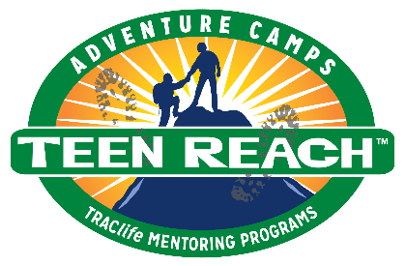
Teen Reach Adventure Camp

Dear Foster Parent/Legal Guardian,

Thank you for completing the Teen Reach Adventure Camp application for
your foster teen. She/he has officially been accepted to attend T.R.A.C this
summer.

Registration will begin at Click of tap to enter time on Click or tap to enter a date., the first

day of camp, at Click or tap here to enter registration location.

Please do not call the office; they are not a contact for T.R.A.C.

Please use the enclosed Registration Check List to ensure your teen is prepared

for camp, this includes preparing/requesting any medications they may

need in original bottles only.

There will be multiple stations at T.R.A.C. Registration to ensure your teen has a

successful camping experience, but please follow all instructions carefully.

Please pre-check your camper's gear for any questionable* items. We will search all

gear at registration and will confiscate any inappropriate items.

Please call Click or tap here to enter name at Click or tap here to enter phone number if you have
any questions about camp or registration.

All campers will return to the registration location on Click or tap to enter a date.,
by Click or tap to enter time. If someone other than you will pick up your teen from camp,
please let the Camp Director or Registration Supervisor know. By law, we will
not be able to release him/her to another person without prior notification.

Thank you for sending your teen to Teen Reach Adventure Camp!

Sincerely,

Camp Director
*All electronic item s, tobacco or illegal drugs, questionable reading material, dangerous weapons.
Please contact the cam p director if you would like further clarification on items not allowed at Teen
Reach Adventure Cam p.
Teen Reach Adventure Camp

REGISTRATION CHECKLIST

(Please bring this list to registration)

Camper Name:
Guardian Name: |  | Phone Number:
Case Worker’s Name: |  | Phone Number:

Required prior to registration, for your child to attend T.R.A.C.:

Camper Application, complete and accurate
Recent photo of camper (sent with application)
Signed releases for facility activities (zipline, horses, etc.), if required.
Medication confirmed with physician for accuracy (dosage/original container)
Lice shampoo (RID) treatment three (3) days prior to camp
Registration fee (if required) – submitted with Camper Application

Campers should also bring the following items for camp.

Packing List – Teen Reach Adventure Camp

 | Sleeping bag/blankets |  |  | Undergarments (5 pair)
 | Pillow/sheets |  |  | Socks (5 pair)
 | Old sneakers/hiking boots |  |  | Sweatshirt/Jacket (two)
 | Jeans/long pants (2 pair) |  |  | Towel (two)
 | Shorts (2 pair) |  |  | Swimsuit (no bikinis)
 | Shirts (three) |  |  | Toiletries

In addition to the preparations listed above, your teen must be able to hike at least two
miles.

Thank you for preparing your teen for a successful T.R.A.C. experience.

Teen Reach Adventure Camp Leadership

