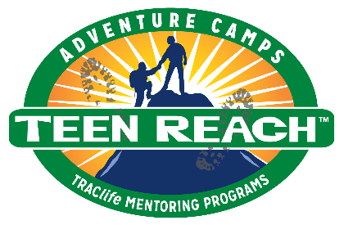

Teen Reach Adventure Camp
A camp for at-risk youth, Ages 12 – 15, usually residing in foster care.

Teen Reach Adventure Camp (T.R.A.C.) is a positive, faith-based summer camp
experience especially designed to ensure success for at-risk youth, usually
residing in foster care, who have likely experienced abuse, abandonment or
neglect.

Each three-day camp focuses on safety by providing a unique ratio of one
camp counselor to every two campers. Rather than being co-ed, each camp is single-
sex to promote a greater level of comfort between staff and attendees.
Volunteers are thoroughly screened and trained. And, each camp has a nurse and
a licensed social worker or mental health professional (behavioral specialist) who
are available to meet the needs of campers.

Every youth is offered complete confidentiality. No volunteers will take photos,
other than the camp photographer who will take pictures for individual camper
photo albums. All T.R.A.C. promotional videos/pictures will be edited for
confidentiality.

Campers explore the wilderness, enjoy waterfront activities, make crafts and
participate in a low-level challenge course designed to build self-respect,
teamwork, trust and communication while having fun. Through encouragement
and quality time with each teen, volunteers at T.R.A.C. strive to give campers a
sense of hope that the past doesn’t have to define the future.

If you have any questions, please e-mail: Click or tap here to enter Camp Director or Child Placement Coordinator email address
Click here to enter local T.R.A.C. website or delete this line.

