Last Updated 1/19

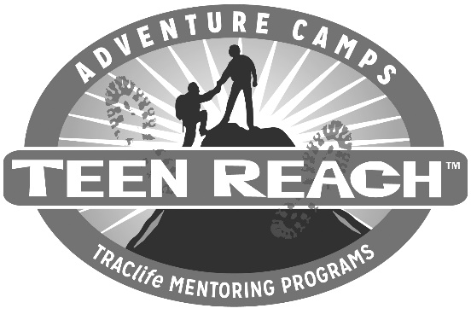

DATE

Dear Legal Guardian/Case Worker,

T.R.A.C.life is a mentorship program that provides safe, bi-monthly (twice a month) visits between campers and staff who have connected at Teen Reach Adventure Camp. T.R.A.C.life is operated at a national level, but trains directors and mentors at a local level to serve campers at _____________________ (camp name).
We are sending ____________________ an application because he/she expressed an interest in mentoring. The enclosed application needs to be signed for the teen to participate. In addition, we need a copy of his/her medical card for our records. All information will be kept confidential. There is no cost to you.
Thank you for what you do every day. We hope T.R.A.C.life will be a great experience for your foster teen while offering respite to you.

Respectfully Yours,

T.R.A.C.life Director

