Click here to enter camp name T.R.A.C.
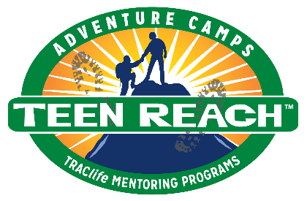

Dear Guardian,

We are pleased to send you this application for Click here to enter camp name Teen Reach

Adventure Camp (T.R.A.C.), a camp especially designed for at-risk youth, usually residing in

foster care, who may have been abused, abandoned or neglected.

Currently, T.R.A.C. is opening enrollment to returning campers and graduates of local Royal

Family KIDS Camps. Open registration ends Click here to enter a date, so please make camp a

priority for your teen(s) by returning this application before this date.

We can’t wait to see your teen at camp. Please return the completed application as soon as
possible. You are instrumental in your teen’s success, and we appreciate your commitment.

If you have any questions, please call or email: Click here to enter Camp Director phone and/email

Sincerely,

Click here to enter Director(s) name(s)
Camp Director(s)

