Last Updated 1/19

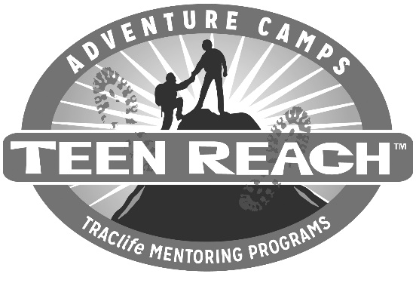

DATE

Dear (Prospective Mentor),

Thank you for your interest in becoming a mentor for T.R.A.C.life. You will be making a difference in the life of a teenager as you give of yourself unselfishly.
Enclosed is an application. Please fill it out completely. In addition, please send a copy of your driver’s license and your automobile insurance with your application. Your personal information will be kept confidential.
After your application is processed, including reference checks, we will call you for a personal interview. A fingerprinted background check will need to be completed before training. Thank you for your patience as you undergo this rigorous process.
Once again, we want to thank you for your interest in becoming a mentor for T.R.A.C.life.

For His Teens,

T.R.A.C.life Director, (area serving)

