Last updated 1/19
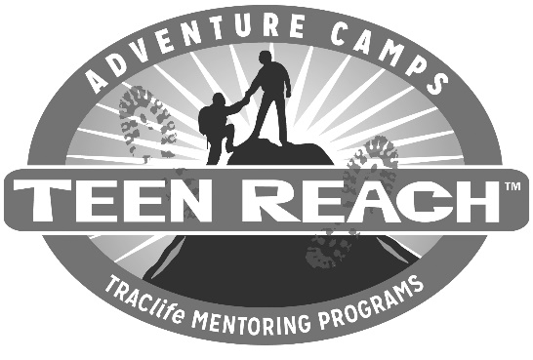

(Date)

Dear (Case Worker and Legal Guardian),

Please be advised that (mentor or mentee) is no longer participating in the T.R.A.C.life mentoring program. Please be aware that this commitment has now ended, and any future contact between (mentee) and (mentor) will not be supervised nor monitored by T.R.A.C.life. T.R.A.C.life will not be responsible for any future interaction between (mentor) and (mentee) unless both parties complete the application process again and are approved for the T.R.A.C.life program. Please take whatever steps you deem necessary to ensure that any future contact between (mentor) and (mentee) is in the best interest of (mentee). It has been a pleasure working with you planting seeds of hope for (mentee) to reach (his/her) potential.
Sincerely,

__________________________, T.R.A.C.life Director (location)
__________________________, Mentor

